Ch.3 lab 2 Exercises

# Task 1

Write a program that reads three numbers and prints “all the same” if they are all the same, “all different” if they are all different, and “neither” otherwise.

**Output 1:**

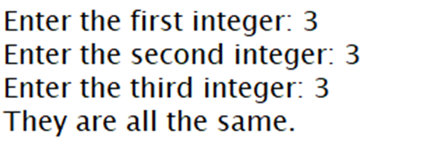

**Output 2:**

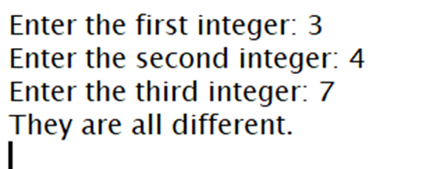

|  |
| --- |

|  |
| --- |

|  |
| --- |

# 

# Task 2

Given the string:

str = " Hello, World “

*Hint: there are 3 spaces before and after the word*

**Print the following (use only the string methods we discussed to print):**

* count how many letter L’s
* string with 3 leading and trailing stars and no space around
* string with stars and no space on the left
* string with stars and no space on the right
* string with o's replaced with ***

**Sample output:**

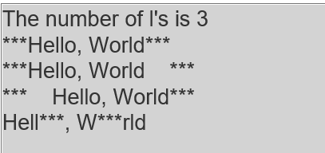

|  |
| --- |

|  |
| --- |

**Note:**

**Your code must demonstrate the count, strip, lstrip, rstrip and replace methods**